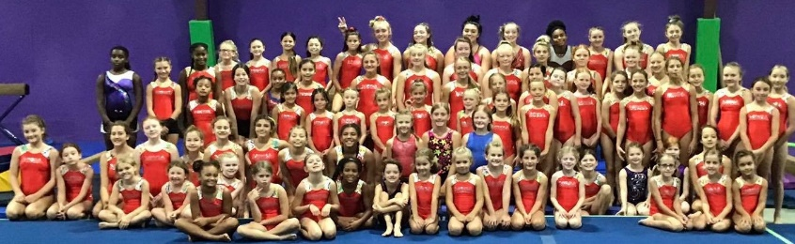
2021 OKlahoma team ‘mega’ camp
For girls July 16 – 17 $150
This camp is open to all Girl Gymnasts.
You do not need to be a member of MEGA Gymnastics to attend this camp.
Team coaches from other gyms are welcome to shadow your gymnast during camp if they show proof of USAG or AAU background check and SafeSport course completion.

Schedule: July 16 8-9am Check in
9-noon Workout
12-1pm Lunch (not provided)
1-2pm Open Gym
2-5pm Workout
7-9pm Private Pool Party (if city covid protocols permit)

July 17 9-noon Workout
12-1pm Lunch (not provided)
1-2pm Open Gym
2-5pm Workout
***Sunday, July 18 9-noon Connections & Flight Cost is additional $25.
(Must have Glide Kip Cast to Handstand and Beam Back Handspring before camp to attend this special session)

*add $75 for 2 different camp leo’s with your gyms’ name on front
This camp is designed for girls who have a minimum solid ‘back handspring.’
16,850 sq ft of gymnastics space. 2 buildings full of equipment. inground trampoline.pit for tumbling, vaulting, bar work. tumbletrak and so much more.
This intensive camp is perfect for your gymnasts Summer Camp experience.
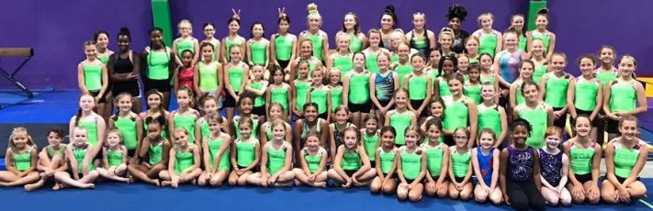
2021 OKlahoma team ‘mega’ camp
For girls July 16 – 17

Registration and Medical Release Form. A deposit of $100.00 must accompany this application form. Deposits are applied toward the tuition and are non-refundable after June 3rd. Make checks payable to: MEGA Gymnastics, 13 E. Jackson Ave, McAlester, OK 74501

GYMNAST’S NAME: ________________________ AGE: __________ T-shirt Size: ___________
Check one __________ July 16-17 ___________ July 16-18
Leo Size (if purchasing 2 Camp Leos with your gyms’ name on them): _________________ ($75 by 6/3)

USAG LEVEL for 2021-22 Season: __________________ Home Gym: ______________________

PARENT/GUARDIAN NAME: _______________________________________________________

E-MAIL: ____________________________ ADDRESS: ________________________________

CITY, STATE, ZIP: ____________________________________ PHONE: __________________

Emergency Contact Name/Phone #: _____________________________________
Having been informed of the activities to be conducted by the McAlester Elite Gymnastics Academy, LLC (aka MEGA Gymnastics) I, a parent or guardian of the participant, give my approval for the above named student’s participation in any and all activities of the program. I assume all risks and hazards incidental to the program, including transportation to and from these activities. I further release, waive, and forever discharge any and all rights and claims against McAlester Elite Gymnastics Academy llc aka MEGA Gymnastics, its owners, instructors and employees, holding them harmless from any injury of the participant occurring during the program. Furthermore, I hereby authorize the directors of the MEGA Gymnastics to act for me according to their best judgment in any emergency requiring medical attention. I know of no mental or physical problems which affect my child’s ability to safely participate in this camp.

Signature of Parent, Guardian:______________________________________ Date:__________________

